SOP How to unlock and reset user id in Apps Manager

Step 1 :- Login to the URL of Apps Manager https://appmgr.salam.sa/
Step 2:- Navigate to the admin path product settings User Management. We will be seeing an page like ne mentioned below,
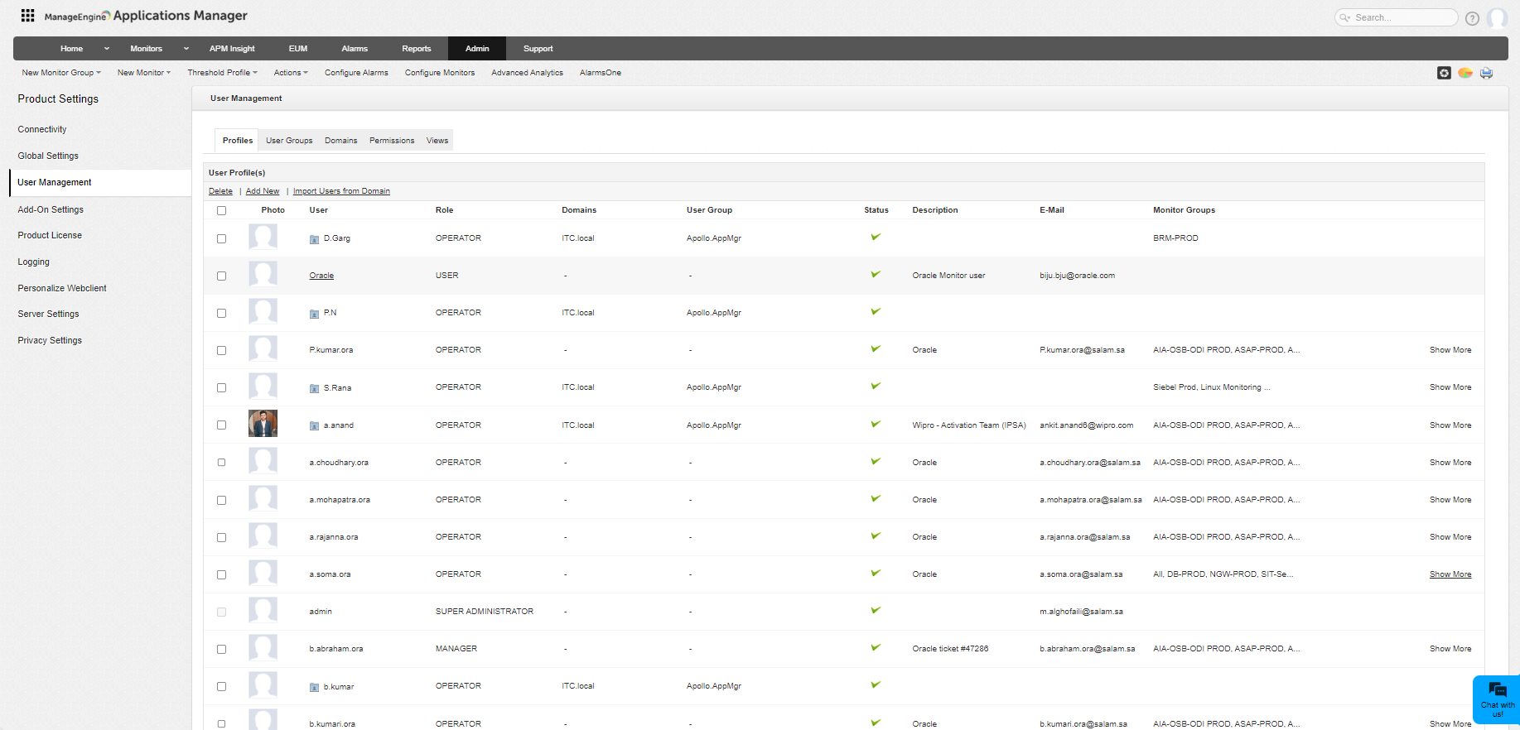
Step 3:- as part of this phase , you will have access to user add, delete, update user password, role, privilege, delete user.
Step 4:- standard template for Apps Manager which all our Team must have is given below for reference.
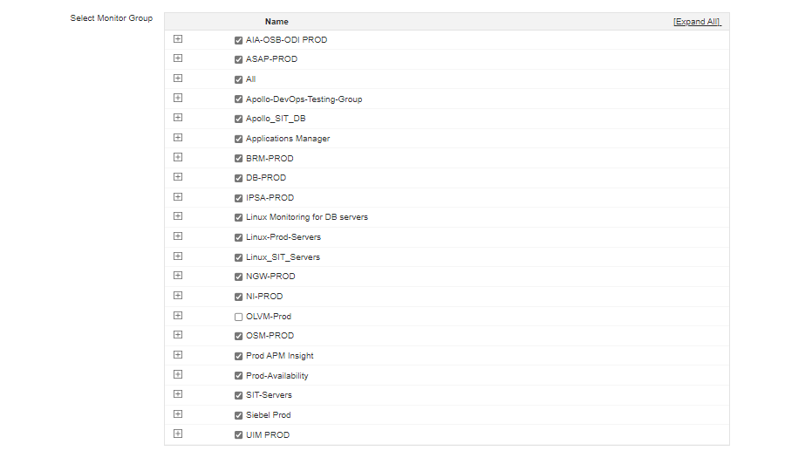
Step 5:- for new user add click user add, under description update SD Tciket number with which you are creating user access, this is mandatory for audit
Step 6:- while resetting or unlocking the password please mention the details if requested because we need this input for audit.
Step 7:- we have 4 roles defines under apps manager,

- Operator generic access for all dashboard under apps manager configured by any admin
- Administrator this user will have complete access, to all dashboard and also to define any new customization. If this user add an new dashboard he must make sure to update that new group added must be added to all operator profile for visibility
- User basic read only access
- Manager will have the privilege for the SLA and reports.
Some images for user add and delete are given below.
Note:- for any action we take please always mention the SD # this is mandatory for all request action we do , this is needed for auditing.
Ensure to click update user after all changes we do.
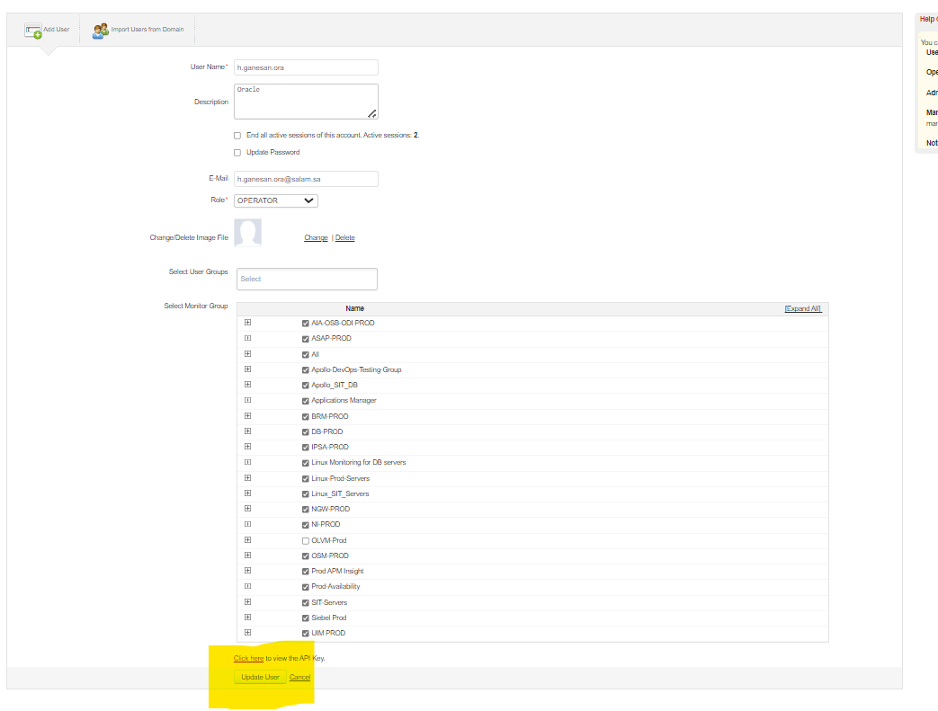
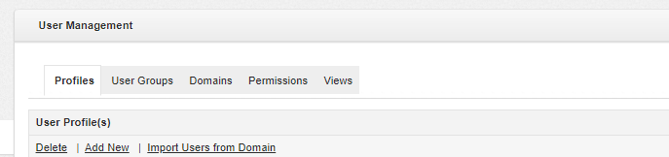
Always select the local authentication, since there is challenges existing to use the ad id user have.

Please keep this document updated after every new changes happen to the portal

